Chapter 2:

2.1:

* Flowers are purchased at an auction
* Flowers are inspected and transported

2.2:

* Piece production is a company that produces unique items
* Mass production is a company that produces mass products

2.3:

* Unique mix of ways to add value determines the positioning of the company
* For example: by allowing customers to offer a helpdesk with questions

2.4:

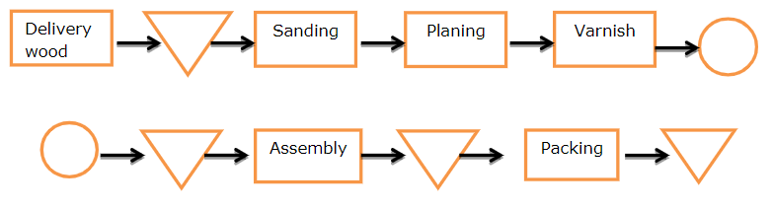

2.5:

* Primary and secondary market research

2.6:

* Making customers happy
* Right customers for the right products

2.7:

* By purchasing on favorable conditions

2.8:

* Place: where do I sell
* Price: for how much do I sell
* Promotion: how do I advertise my product
* Product: what do I sell
* Personnel: who are my staff

2.9:

* Small adjustments to appeal to the customer

Thurston Kitchen and Bath

1. Integrated network for faster communication
2. Network solution is easier for customers to connect with staff
3. Producing and selling kitchen and bathroom equipment

Chapter 3:

3.1:

* Facility manager supports primary activities: buildings are well maintained, safe, right climate

3.2:

* Operational: clean, rubbish control
* Safety: fire safety, smoke alarms, alarm system
* Hygiene: air quality, cleaning dangerous substances
* Security: access control, camera observation
* Maintenance: maintenance of building and systems

3.3:

* ICT are improving primary activities

3.4:

* Communication is important for all in the company

3.5:

* Intake: recruitment and selection of new employees
* Internal mobility: career development
* Outplacement: exit interviews
* Function structuring: task structuring, function management
* Personnel planning: making plans for employees
* Personnel administration: all proceedings must be administrated
* Communication and information: communication between employees and bosses

3.6:

* Financial accounting is important for management

3.7:

* The time it takes to design, develop, and sell a new product

3.8:

* Preliminary research 🡪 Analysis 🡪 Design craft 🡪 Detailed design 🡪 Realization 🡪 After-sales

Textbook sales:

* Communication supports marketing with developing and shaping the right message.
* Research and development could, for example, support the logistics process.
* Human resources could, for example, support sales and service by hiring and training the right staff.
* Administration supports marketing with delivering the correct market data.
* Finance supports the purchase department with pricing information and development data.
* ICT supports sales with food working PCs and crm software.
* Legal Affairs ensures that the correct purchase and sales condition are met.
* Facility management ensures that storage of the records takes place in a space that is well ventilated and not humid.

Chapter 4:

4.1:

* Internal interest parties: owner, employees
* External interest parties: suppliers, advertising media, customers

4.2:

* Macro context: political and economic situation which determines the money available for healthcare
* Transactional context: insurance companies that want to decide to which hospitals their clients can go

4.3:

* The STEP analysis describes the transactional context

4.5:

* Rivalry between competitors; Negotiating power of suppliers; Threat of new entrants; Threat of substitutes; Negotiating power of buyers

4.6:

* Turbulent environment is complex and dynamic

4.7:

* Water companies: no competition, not much technological innovation

4.8:

* The macro context

4.9:

* The brand has invested worldwide in production and vending capacities, leaving the business would be a large disinvestment

4.10:

* Large investments but also access via Dutch Government to the tracks that belong to Prorail

Coca Cola:

1. Consumers could refrain from drinking
2. Social elements: how will the consumers react; Political: will there be a political response
3. Industry Rivalry; Buyers; Potential substitutes; Suppliers; Potential entrants
4. Get scientific proof from top institutes which are trusted by the general public